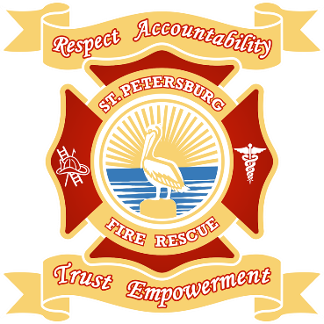
St. Petersburg Fire Rescue 7th Annual Awards Banquet
Sean Kilgannon, Chairman Jenna Knippen, Vice Chair Lt. Rob Neuberger, Logistics

Dear,

On behalf of the St. Petersburg Fire Rescue Banquet Committee, I am pleased to announce the upcoming 7th Annual Fire Rescue Awards Banquet. We welcome this opportunity to raise money for the St. Petersburg Firefighters Charity Fund while also recognizing the outstanding public servants of our community.

This year’s banquet will take place on November 17th at the Hilton St. Petersburg Bayfront. The formal event will include dinner, an open bar, live entertainment, and presentation of the Fire Officer, Firefighter, EMT, and Paramedic of the year. As with previous years, the success of this event is largely dependent on the generosity of sponsors in our community. We humbly request your support, in the form of sponsorship, to make this year’s event a success

In the past, we have had the privilege to present all proceeds from the banquet to local charities such as Pet Pal Animal Shelter, Suncoast Hospice, Pinellas Hope, CASA, and PARC. This year’s funds will go to support the Heroes of St. Pete Police and Fire, Inc. in their mission to honor fallen officers and firefighters, and to provide financial support for these first responders and their families in times of crisis and tragedy.

Enclosed, please find an addendum explaining the advertising opportunities available to you, as well as an explanation of the benefits included with each level of donation. The event will also feature a raffle and auction of items and services provided by local businesses, should you wish to contribute in that manner.

Thank you for taking the time to consider a contribution to our event. As public service members, we relish this opportunity to further demonstrate our gratitude and commitment to the community.

Checks can be made payable to our 501c3: St. Petersburg Firefighters Charity Fund Inc.

Please send your sponsorship to: St. Petersburg Fire Rescue
Attn: Jenna Knippen-Operations
400 Dr. MLK Jr. St. S.
St. Petersburg, FL 33701

We hope you can join us along with our Local and State dignitaries for this special evening!

Sincerely,
Sean Kilgannon
Chairman
SPFR Awards Banquet Committee
(727) 551-3358 sean.kilgannon@stpete.org

